**JAVA LAB QUESTIONS**

MCA202 JAVA PROGRAMMING

**CYCLE 1: Basic programs using datatypes, operators and control statement in java (Due by: 18-01-2024)**

1. Write a Java program to check whether a string is palindrome or not.
2. Write a Java program to multiply two matrices
3. Write a Java program to find the transpose of a matrix.
4. Write a Java program to find the second smallest element in an array.
5. Write a Java program to check whether a number is prime or not.
6. Write a java program to demonstrate Bitwise logical operators, left shift and right shift operators.
7. Write a java program to find the roots of a quadratic equation.

**CYCLE 2: Object Oriented Concepts (Due by: 23-01-2024)**

1. Write a Java program to calculate the area of different shapes namely circle, rectangle, trapezoid and triangle. (Use the concepts of JAVA like *this* keyword, constructor overloading and method overloading)
2. Define a class called Rectangle with member variables length and width. Use appropriate member functions to calculate the perimeter and area of the rectangle. Define another member function *int sameArea(Rectangle)* that has one parameter of type Rectangle. *sameArea* returns 1 if the two Rectangles have the same area, and returns 0 if they don't. Use appropriate constructors to initialize the member variables(Use both default and parameterized constructor)
3. Write a main function to create two rectangle objects and display its area and perimeter. Check whether the two Rectangles have the same area and print a message indicating the result. (Use the concept of *this* pointer too)
4. Write the definition for a class called Complex that has floating point data members for storing real and imaginary parts. Define a function *Complex sum(Complex)* to add two complex numbers
5. & return complex number. Write main function to create three complex number objects. Set the value in two objects and call *sum()* to calculate sum and assign it in third object. Display all complex numbers. (Use the concept of *this* pointer too.)
6. Define a class called Time that has hours and minutes as integer. The class has the following member function: *Time sum(Time)* to sum two time object & return time a. Use the concept of constructor overloading to initialize the time
   1. Write the definitions for each of the above member functions.
   2. Write main function to create three time objects. Set the value in two objects and call sum() to calculate sum and assign it in third object. Display all time objects. (Use the concept of *this* pointer too)

5. Create a class ‘Account’ with two overloaded constructors. The first constructor is used for initializing the name of account holder, the account number and the initial amount in the account. The second constructor is used for initializing the name of the account holder, the account number, the addresses, the type of account and the current balance. The Account class is having methods Deposit (), Withdraw (), and Get_Balance(). Make the necessary assumption for data members and return types of the methods. Create objects of Account class and use them.

**CYCLE 3: Inheritance, method overloading and overriding, Polymorphism (Due by: 28-01-2024)**

1. Write a Java program which creates a class named 'Employee' having the following members: Name, Age, Phone number, Address, Salary. It also has a method named 'print- Salary( )' which prints the salary of the Employee. Two classes 'Officer' and 'Manager' inherits the 'Employee' class. The 'Officer' and 'Manager' classes have data members 'specialization' and 'department' respectively. Now, assign name, age, phone number, address and salary to an officer and a manager by making an object of both of these classes and print the same.
2. Write two Java classes Employee and Engineer. Engineer should inherit from Employee class. Employee class to have two methods display() and calcSalary(). Write a program to display the engineer salary and to display from Employee class using a single object instantiation (i.e., only one object creation is allowed).
   * display() only prints the name of the class and does not return any value. Ex. “ Name of class is Employee.”
   * calcSalary() in Employee displays “Salary of employee is 10000” and calcSalary() in Engineer displays “Salary of employee is 20000.”
3. Write a Java program to implement the following level of inheritance.

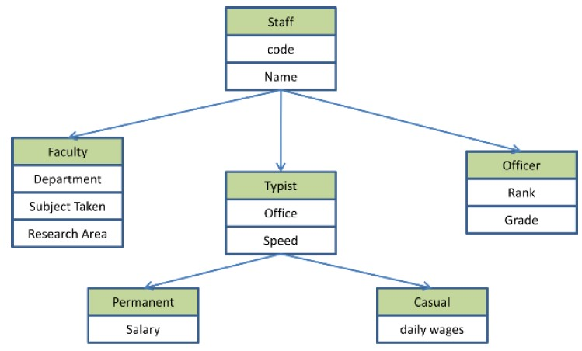

1. Write a java program to create an abstract class named Shape that contains an empty method named numberOfSides(). Provide three classes named Rectangle, Triangle and Hexagon such that each one of the classes extends the class Shape. Each one of the classes contains only the method numberOfSides( ) that shows the number of sides in the given geometrical structures.
2. write a program to represent geometric shapes and some operations that can be performed on them. The idea here is that shapes in higher dimensions inherit data from lower dimensional shapes. For example a cube is a three dimensional square. A sphere is a three dimensional circle and a glome is a four dimensional circle. A cylinder is another kind of three dimensional circle. The circle, sphere, cylinder, and glome all share the attribute radius. The square and cube share the attribute side length. There are various ways to use inheritance to relate these shapes but please follow the inheritance described in the table below.

All shapes inherit getName() from the superclass Shape.

Specification:

Your program will consist of the following classes: **Shape, Circle, Square, Cube, Sphere,** **Cylinder,** and **Glome** and two interfaces **Area** and **Volume**

Your classes may **only** have the class variable specified in the table below and the methods defined in the two interfaces Area and Volume. You will implement the methods specified in the Area and Volume interfaces and have them return the appropriate value for each shape. Class Shape will have a single public method called getName that returns a string.

|  |  |  |  |  |
| --- | --- | --- | --- | --- |
| **Class** | **Class Variable** | **Constructor** | **Extends** | **Implements** |
| Shape | String name | Shape() |  |  |
| Circle | double radius | Circle( double r, String n ) | Shape | Area |
| Square | double side | Square( double s, String n ) | Shape | Area |
| Cylinder | double height | Cylinder(double h, double r, String n ) | Circle | Volume |
| Sphere | None | Sphere( double r, String n ) | Circle | Volume |
| Cube | None | Cube( double s, String n ) | Square | Volume |
| Glome | None | Glome( double r, String n ) | Sphere | Volume |
| Note: the volume of a glome is 0.5(π2)r4 where r is the radius. | | |

1. Define an interface “Operations” which has method area(), volume(). Define a constant PI having value 3.14. Create class a Cylinder( with member variable height) which implements this interface. Create one object and calculate area and volume. Add Required Constructors.
2. Write a program that illustrates interface inheritance. Interface **P** is extended by **P1** and **P2**. Interface **P12** inherits from both **P1** and **P2**.Each interface declares one constant and one method. class **Q** implements **P12**.Instantiate **Q** and invoke each of its methods. Each method displays one of the constants.

**Cycle 4: Multithreading (Due by: 05-02-2024)**

1. Write a Java program to create two threads: One for displaying all odd number between 1 and 100 and second thread for displaying all even numbers between 1 and 100. Create a multithreaded program by creating a subclass of *Thread* and then creating, initializing, and starting two *Thread* objects from your class. The threads will execute concurrently Main thread should wait until all the other thread terminates its execution(using join()).

1. Write a Java program that set thread priorities and display the priority.

1. Write a java program that implements a multi-thread application that has three threads. The first thread generates random integer every 1 second and if the value is even, second thread computes the square of the number and prints. If the value is odd, the third thread will print the value of cube of the number

1. Write a program to illustrate creation of threads using runnable interface. (*start* method start each of the newly created thread. Inside the *run* method there is *sleep()* for suspend the thread for 500 milliseconds). Main thread should wait until all the other thread terminates its execution (using join()).

1. Write a java program showing a typical invocation of banking operations via multiple threads. Create three threads and 2 methods deposit and withdraw methods to add the amount to the account and withdraw an amount from the account respectively. As the threads concurrently run the method, avoid the unpredictable behavior. (Use synchronization).

**Cycle 5 Input-Output, File Management and exception handling (Due by: 15-02-2024)**

1. Write a Java Program to merge data from two files into a third file. (Handle all file related exceptions)

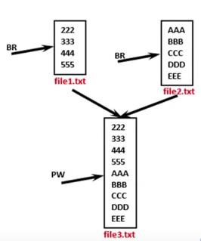

1. Write a Java Program to perform file merge operation where merging should be done by line by line alternatively. (Handle all file related exceptions)

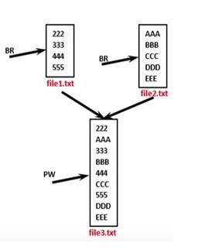

1. Write a Java program that reads a set of real numbers from a file and displays the minimum, maximum, average, and range of the numbers in the file. The user should be able to enter the name of the input file from the keyboard.

1. Write a program that reads the contents of a file and creates an exact copy of the file, except that each line is numbered. For example, if the input file contains the following text:

Two roads diverged in a yellow wood,

And sorry I could not travel both

And be one traveler, long I stood

And looked down one as far as I could

To where it bent in the undergrowth;

then the output file should appear something like this:

1: Two roads diverged in a yellow wood,

2: And sorry I could not travel both

3: And be one traveler, long I stood

4: And looked down one as far as I could

5: To where it bent in the undergrowth;

The user should be able to enter the names of the input and output files from the keyboard.

1. Write a Java program that reads a line of integers, and then displays each integer, and the sum of all the integers. (Use StringTokenizer class of java.util)
2. Write a Java program that displays the number of characters, lines and words in a text file.

1. Create a class Student with attributes roll no, name, age and course (use user inputs).If age of student is not in between 15 and 21 then generate an exception to handle it.

1. Write a Java program to define a class salesman with the attributes name, salesman code, sales amount and commission(use user inputs). The Company calculates the commission of a salesman according to the following formula:
   1. 8% if sales <2000
   2. 10% sales if sales>=2000 and but <=5000
   3. 12% if sales exceeds 5000

Create salesman objects and find the commission of sales. **Generate and handle exceptions if sales amount is less than 0.**

**Cycle 6: Networking (Due by: 22-02-2024)**

1. Download the content of file from the internet
2. Make a public chatting program using TCP/IP
3. Make a peer to peer messaging program using UDP

**Cycle 7: Database PRogramming (Due by: 28-02-2024)**

1. Construct the following tables:

Department (dno(Primary), dname, dloc)

Emp ( eno(Primary), ename, esal ,dno(Foreign))

1. Write a program for displaying information in the following order from the above tables:

**eno ename esal dname dloc**

1. Chetan 10,000 Civil Kochi
2. Amish 20,000 Accounts Delhi
3. Program to implement database connectivity using object oriented concepts.
4. Write a JDBC program with Parametrized queries to update a given record (Rani’s salary to 15,000) in the Emp table.
5. Write a JDBC program with Parametrized queries to list the records of Emp table which has records whose names start with the alphabet “R”.
6. Write a JDBC program with PreparedStatement to delete the records of Emp table which has records whose salary is less than 10,000.
7. Implement a JDBC program which uses a Stored Procedure to insert records into Department table.
8. Use Callable statement to implement a Stored Procedure to display the Ename and Salary of all employees.
9. Write a JDBC program to implement Transaction Management in the Department table.
10. Write a JDBC program to depict the usage of SQLException Class and SQLWarning Class

**Cycle 8: Graphics Programming (Due by: 03-03-2024)**

1. Write a Java program that works as a simple calculator. Arrange Buttons for digits and the + - * % operations properly. Add a text field to display the result. Handle any possible exceptions like divide by zero. Use Java Swing.
2. Write a Java program that simulates a traffic light. The program lets the user select one of three lights: red, yellow, or green. When a radio button is selected, the light is turned on, and only one light can be on at a time. No light is on when the program starts.

**Cycle 9: Collection Framework (Due by: 10-03-2024)**

1. Write a Java program for the following: **
   1. Create a doubly linked list of elements.
   2. Delete a given element from the above list.
   3. Display the contents of the list after deletion.

1. Write a Java program that implements Quick sort algorithm for sorting a list of names in ascending order.

**Cycle 10: Capstone Project ((Due by: 20-03-2024)**